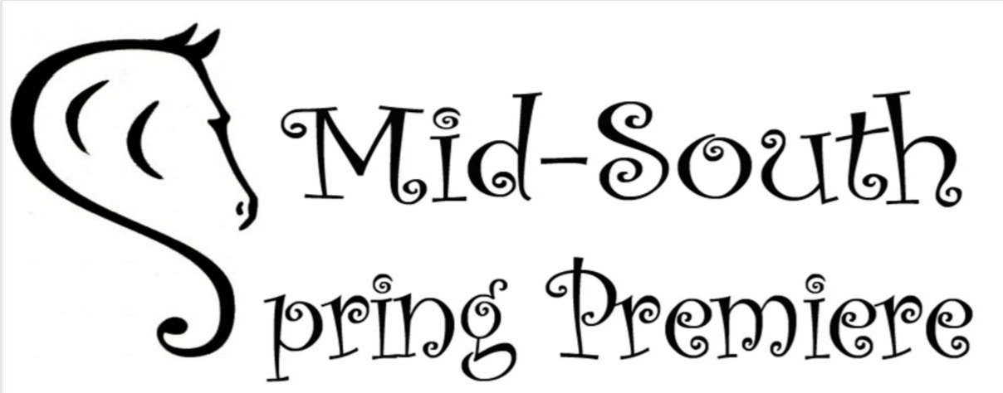

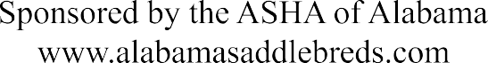

**May 22nd – 24th 2025**





**Judge – Jon Walker**

**Gastonia, NC**

Entry Closing Date – May 8th

|  |  |
| --- | --- |
| **Show Secretary** | Janie Hamilton – Hixson, TN |
| **Announcer** | Travis Olinger – Cleveland, TN |
| **Paddock Master** | Danielle Kunz – Birmingham AL |
| **Ringmaster** | Pat Tate – Wilsonville, AL |
| **Blacksmith** | Hayden Jones - GA |
| **Photographer/Video** | Event Mix |

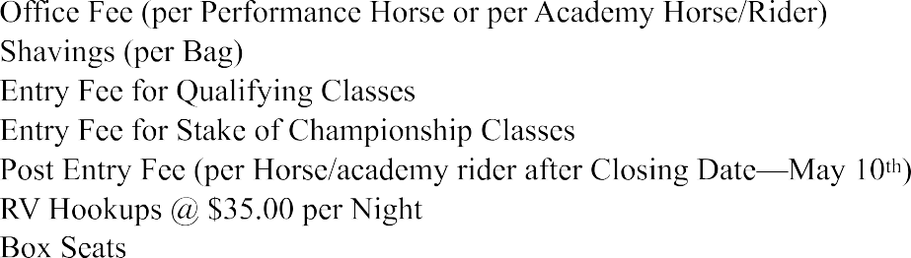



$45

$35

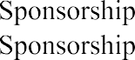

Stall Fee (Available for horses May 20th)



**Entries:** Entries close May 8th, 2025 and must be postmarked by that date. Any entries postmarked after this date will be considered post entries and pay a $20.00 per horse/academy rider post entry fee.

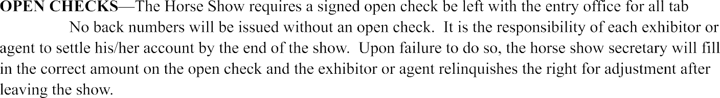

**Stalls and Reservations**: stall and tack stalls are $130 each. No stall will be assigned until the stall payment is received (open check OK). Stalls available Tuesday, May 20th 2025.



**Refunding of Fees:** a full refund will be given to anyone who cancels their entries before the closing date. After the closing date, stall refunds will given only if the stalls are re-rented. Entry fees wil be refunded to anyone who cancels up to one hour prior to the start of the sessions in which they are showing.



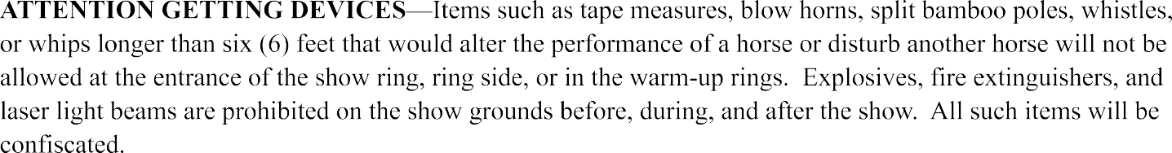

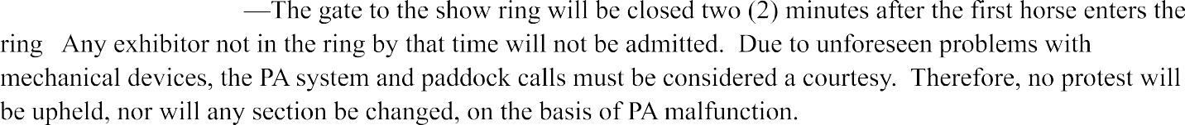



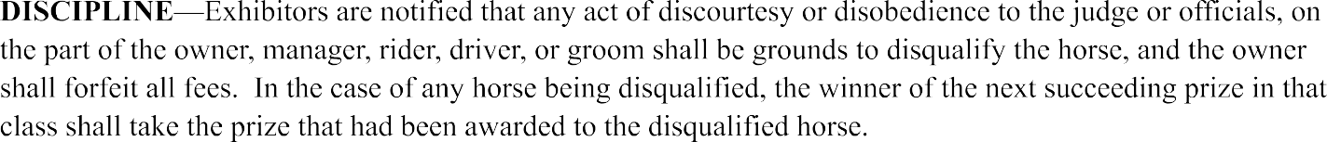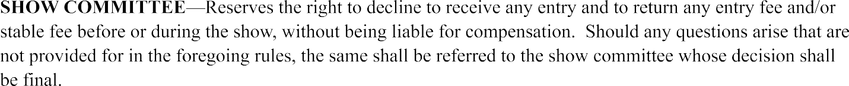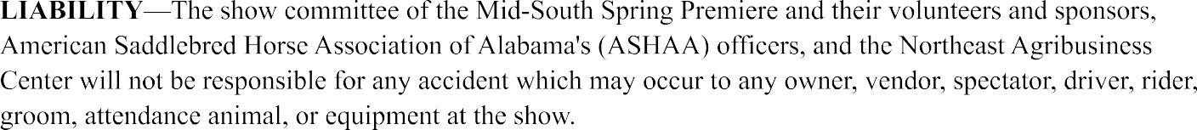



## CLASS SCHEDULE

### THURSDAY EVENING, May 22nd (6:00 P.M.)

1. ASB Fine Harness--Open
2. ASB Three-Gaited Park—Adult Amateur

2A. ASB Three-Gaited Park – Junior Exhibitor

1. ASB Western Country Pleasure--Amateur
2. Five Gaited Pony
3. **Add a class ($150 sponsorship)**
4. ASB Three-Gaited English Country Pleasure--Adult Amateur
5. ASB Hunter Country Pleasure—Junior Exhibitor/Adult Amateur
6. Three Gaited Pony
7. ASB Three-Gaited English Show Pleasure--Junior Exhibitor
8. ASB Three-Gaited English Country Pleasure--Junior Exhibitor
9. ASB Three-Gaited —Adult Amateur

11A. ASB Three-Gaited – Junior Exhibitor

1. ASB Three-Gaited—Open
2. Single Roadster Pony to Bike—Open
3. ASB Five-Gaited Show Pleasure—Adult Amateur

14A ASB Five-Gaited Show Pleasure—Junior Exhibitor

1. Roadster Horse to Bike--Open
2. ASB Five-Gaited--Adult Amateur

16A ASB Five-Gaited--Junior Exhibitor

1. ASB Three-Gaited English Show Pleasure--Adult Amateur
2. ASB Five-Gaited—Open

### FRIDAY MORNING, May 23rd (10:00 A.M.)

### ASB Country Pleasure Driving

1. Walk-Trot Saddle Seat Equitation—10 Years and Under
2. ASB Five Gaited Country Pleasure—Junior Exhibitor/Adult Amateur
3. ASB Five Gaited Three Year Old
4. ASB Three Gaited Park Pleasure Junior Exhibitor/Adult Amateur
5. Single Hackney or Harness Pony Pleasure Driving—Adult Amateur/Junior Exhibitor
6. ASB Three-Gaited Show Pleasure AL/TN/GA Owned
7. **Add a class ($150 sponsorship)**
8. English Pleasure Walk/Trot--Open (Saddle Seat or Hunt) (Any Breed)
9. ASB Three Gaited Park Three Year Old
10. Pleasure Pony -- Rider 17 and Under (Any Breed)
11. Road Horse Under Saddle
12. Saddle Seat Pleasure Walk/Trot--Rider 12 and Under (Any Breed)
13. English Pleasure--Open (Saddle Seat or Hunt Seat)
14. ASB Show Pleasure Driving
15. ASB Three-Gaited English Country Pleasure AL/TN/GA Owned
16. Alpha Rider English Pleasure
17. ASB Fine Harness Three Year Old

### FRIDAY EVENING, May 23rd (6:00 P.M.)

### ASB Fine Harness--Amateur

1. Five Gaited Pony –Championship
2. **Add a class ($150 sponsorship)**
3. ASB Three-Gaited Park Pleasure--Open
4. Roadster Pony Under Saddle
5. ASB Western Country Pleasure Amateur Championship
6. Three Gaited Pony --Championship
7. ASB Five-Gaited Show Pleasure—Limit Rider
8. ASB Three Gaited Three Year Old
9. Saddle Seat Equitation--Open (17 Years and Under) (Any Breed)

46A. Adult Saddle Seat Equitation

1. Single Roadster Pony to Bike—Amateur/Junior Exhibitor
2. ASB Three-Gaited English Country Pleasure--Limit Rider
3. ASB Hunter Country Pleasure--Championship
4. ASB Three Gaited Park Pleasure Three Year Old
5. ASB Three-Gaited English Show Pleasure--Limit Rider
6. ASB Three-Gaited Park--Open
7. ASB Five Gaited Ladies

### SATURDAY MORNING, May 24th (10:00 A.M.)

1. Single Hackney or Harness Pony Pleasure Driving-- Championship
2. Walk-Trot Saddle Seat Equitation—10 Years and Under Championship
3. ASB Show Pleasure Driving-- Championship
4. Pleasure Pony -- Rider 17 and Under Championship
5. English Pleasure Walk/Trot –Open Championship (Saddle Seat or Hunt)
6. Saddle Seat Pleasure Walk/Trot --Rider 12 and Under Championship
7. ASB Five Gaited Country Pleasure –Championship
8. Alpha Rider English Pleasure Championship
9. ASB Country Pleasure Driving--Amateur Championship
10. English Pleasure--Open Championship
11. ASB Three Gaited Park Pleasure Amateur –Championship
12. SESHA Saddle Seat Equitation Medallion--Any Age Amateur
13. **Add a class ($150 sponsorship)**

**30 Minute Break**

1. Academy Pleasure Driving--All Ages
2. Academy Showmanship WTC--Adult
3. Academy Equitation WTC--Adult
4. Academy Showmanship WTC--17 and under
5. Academy Equitation WTC—17 and under
6. Academy WTC Championship
7. Academy Showmanship WT--Adult
8. Academy Equitation WT--Adult
9. Academy Showmanship WT--Rider 11-17
10. Academy Equitation WT--Rider 11-17
11. Academy WT 11 and Over Championship
12. Academy Showmanship WT--Rider 9-10
13. Academy Equitation WT--Rider 9-10
14. Academy Showmanship--Rider 8 and Under
15. Academy Equitation WT--Rider 8 and Under
16. Academy WT 10 and Under Championship
17. Exceptional Rider Equitation—Walk/ Trot Only (Spotters Allowed)
18. Exceptional Rider Showmanship—Walk/ Trot Only (Spotters Allowed)
19. Lead Line--Rider 8 and Under (Walk Only)
20. Academy Lead Line Showmanship WT--Rider 8 and Under
21. Academy Lead Line Equitation WT--Rider 8 and Under
22. **Add a class ($150 sponsorship)**

### SATURDAY EVENING, May 24th (6:00 P.M.)

1. Adult Saddle Seat Equitation--Championship

89A Saddle Seat Equitation--Open (17 Years and Under) Championship

1. Single Roadster Pony to Bike Junior Exhibitor/ Adult Amateur –Championship
2. ASB Three-Gaited English Show Pleasure--Junior Exhibitor Championship
3. ASB Three-Gaited Park--Open Championship
4. ASB Five Gaited Show Pleasure—Adult Amateur Championship

93A ASB Five Gaited Show Pleasure—Junior Exhibitor Championship

1. Roadster Horse to Bike--Open Championship
2. ASB Three-Gaited—Adult Amateur Championship

95A ASB Three-Gaited--Junior Ex Championship

1. ASB Three-Gaited Park Pleasure--Open Championship
2. ASB Three-Gaited English Country Pleasure--Adult Amateur Championship
3. ASB Three-Gaited Park—Adult Amateur Championship

98A ASB Three-Gaited Park—Junior Exhibitor Championship

1. ASB Three-Gaited--Open Stake
2. ASB Five-Gaited—Junior Exhibitor Championship

100A ASB Five-Gaited—Adult Amateur Championship

1. Single Roadster Pony to Bike--Open Championship
2. ASB Three-Gaited English Country Pleasure--Junior Exhibitor Championship
3. **Add a class ($150 sponsorship)**
4. ASB Fine Harness--Open Stake
5. ASB Three Gaited English Show Pleasure--Adult Amateur Championship
6. ASB Five-Gaited--Open Stake

**Class Descriptions**

**Five Gaited:**

|  |  |  |  |
| --- | --- | --- | --- |
| **Number** | **Class Description** | **Schedule** | **Entry Fee** |
| 4 | Pony | Thurs PM | $35 |
| 16 | Adult Amateur – will run concurrently*** | Thurs PM | $35 |
| 16A | Junior Exhibitor – will run concurrently*** | Thurs PM | $35 |
| 18 | Open | Thurs PM | $35 |
| 22 | 3 year old | Fri Am | $35 |
| 38 | Pony Championship | Fri PM | $45 |
| 53 | Ladies | Fri PM | $35 |
| 100 | Adult Amateur Championship– will run concurrently*** | Sat PM | $45 |
| 100A | Junior Exhibitor Championship – will run concurrently*** | Sat PM | $45 |
| 106 | Open Stake | Sat PM | $45 |

**Three Gaited:**

|  |  |  |  |
| --- | --- | --- | --- |
| **Number** | **Class Description** | **Schedule** | **Entry Fee** |
| 8 | Pony | Thurs PM | $35 |
| 11 | Adult Amateur - will run concurrently*** | Thurs PM | $35 |
| 11A | Junior Exhibitor - will run concurrently*** | Thurs PM | $35 |
| 12 | Open | Thurs PM | $35 |
| 43 | Pony Championship | Fri PM | $45 |
| 45 | 3 year old | Fri PM | $45 |
| 95 | Adult Amateur Championship– will run concurrently*** | Sat PM | $45 |
| 95A | Junior Exhibitor Championship – will run concurrently*** | Sat PM | $45 |
| 99 | Open Stake | Sat PM | $45 |

**Fine Harness:**

|  |  |  |  |
| --- | --- | --- | --- |
| **Number** | **Class Description** | **Schedule** | **Entry Fee** |
| 1 | Open | Thurs PM | $35 |
| 36 | 3 year old | Fri AM | $35 |
| 37 | Adult Amateur | Fri PM | $35 |
| 104 | Open Stake | Sat PM | $45 |

**Park:**

|  |  |  |  |
| --- | --- | --- | --- |
| **Number** | **Class Description** | **Schedule** | **Entry Fee** |
| 2 | Adult Amateur – will run concurrently*** | Thurs PM | $35 |
| 2A | Junior Exhibitor– will run concurrently*** | Thurs PM | $35 |
| 28 | 3 year old | Fri AM | $35 |
| 52 | Open | Fri PM | $35 |
| 92 | Open Championship | Sat PM | $45 |
| 98 | Adult Amateur Championship– will run concurrently*** | Sat PM | $45 |
| 98A | Junior Exhibitor Championship – will run concurrently*** | Sat PM | $45 |

**Park Pleasure:**

|  |  |  |  |
| --- | --- | --- | --- |
| **Number** | **Class Description** | **Schedule** | **Entry Fee** |
| 23 | Adult Amateur/Junior Exhibitor | Fri AM | $35 |
| 40 | Open | Fri PM | $35 |
| 50 | 3 year old | Fri PM | $35 |
| 64 | Adult/Amateur/Junior Exhibitor Championship | Sat AM | $45 |
| 96 | Open Championship | Sat PM | $45 |

**Five Gaited Pleasure:**

|  |  |  |  |
| --- | --- | --- | --- |
| **Number** | **Class Description** | **Schedule** | **Entry Fee** |
| 14 | Adult Amateur – will run concurrently*** | Thurs PM | $35 |
| 14A | Junior Exhibitor – will run concurrently*** | Thurs PM | $35 |
| 44 | Limit Rider | Fri PM | $45 |
| 93 | Adult Amateur Championship– will run concurrently*** | Sat PM | $45 |
| 93A | Junior Exhibitor Championship – will run concurrently*** | Sat PM | $45 |

**Three Gaited Show Pleasure:**

|  |  |  |  |
| --- | --- | --- | --- |
| **Number** | **Class Description** | **Schedule** | **Entry Fee** |
| 9 | Junior Exhibitor | Thurs PM | $35 |
| 17 | Adult Amateur | Thurs PM | $35 |
| 25 | AL/TN/GA Owned | Fri AM | $35 |
| 51 | Limit Rider | Fri PM | $35 |
| 91 | Junior Exhibitor Championship | Sat PM | $45 |
| 105 | Adult Amateur Championship | Sat PM | $45 |

**Show Pleasure Driving:**

|  |  |  |  |
| --- | --- | --- | --- |
| **Number** | **Class Description** | **Schedule** | **Entry Fee** |
| 33 | Driving | Fri AM | $35 |
| 56 | Championship | Sat AM | $45 |

**Five Gaited Country Pleasure:**

|  |  |  |  |
| --- | --- | --- | --- |
| **Number** | **Class Description** | **Schedule** | **Entry Fee** |
| 21 | Adult Amateur/Junior Exhibitor | Fri AM | $35 |
| 60 | Championship | Sat AM | $45 |

**Three Gaited Country Pleasure:**

|  |  |  |  |
| --- | --- | --- | --- |
| **Number** | **Class Description** | **Schedule** | **Entry Fee** |
| 6 | Adult Amateur | Thurs PM | $35 |
| 34 | AL/TN/GA Owned | Fri AM | $35 |
| 48 | Limit Rider | Fri PM | $35 |
| 97 | Adult Amateur Championship | Sat PM | $45 |
| 102 | Junior Exhibitor Championship | Sat PM | $45 |

**Country Pleasure Driving:**

|  |  |  |  |
| --- | --- | --- | --- |
| **Number** | **Class Description** | **Schedule** | **Entry Fee** |
| 19 | Driving | Fri AM | $35 |
| 62 | Championship | Sat AM | $45 |

**Western County Pleasure:**

|  |  |  |  |
| --- | --- | --- | --- |
| **Number** | **Class Description** | **Schedule** | **Entry Fee** |
| 3 | Adult Amateur | Thurs PM | $35 |
| 42 | Championship | Fri PM | $45 |

**Hunter Country Pleasure:**

|  |  |  |  |
| --- | --- | --- | --- |
| **Number** | **Class Description** | **Schedule** | **Entry Fee** |
| 7 | Amateur/Junior Exhibitor | Thurs PM | $35 |
| 49 | Championship | Fri PM | $45 |

**Road Horse:**

|  |  |  |  |
| --- | --- | --- | --- |
| **Number** | **Class Description** | **Schedule** | **Entry Fee** |
| 15 | To Bike – Open | Thurs PM | $35 |
| 30 | Under Saddle | Fri AM | $35 |
| 94 | To Bike – Championship | Sat PM | $45 |

**Road Pony:**

|  |  |  |  |
| --- | --- | --- | --- |
| **Number** | **Class Description** | **Schedule** | **Entry Fee** |
| 13 | To Bike – Open | Thurs PM | $35 |
| 41 | Under Saddle | Fri PM | $35 |
| 47 | Adult Amateur/Junior Exhibitor To Bike | Fri PM | $35 |
| 90 | Adult Amateur/Junior Exhibitor To Bike Championship | Sat PM | $45 |
| 101 | Oen To Bike Championship | Sat PM | $45 |

**Hackney Pleasure Pony Driving:**

|  |  |  |  |
| --- | --- | --- | --- |
| **Number** | **Class Description** | **Schedule** | **Entry Fee** |
| 24 | Adult Amateur/Junior Exhibitor | Fri AM | $35 |
| 54 | Championship | Sat AM | $45 |

**Open English Pleasure:**

|  |  |  |  |
| --- | --- | --- | --- |
| **Number** | **Class Description** | **Schedule** | **Entry Fee** |
| 27 | Open Walk/Trot | Fri AM | $35 |
| 29 | Pleasure Pony | Fri AM | $35 |
| 31 | Open Walk/Trot 12 & Under | Fri AM | $35 |
| 32 | Open WTC | Fri AM | $35 |
| 35 | Alpha Rider | Fri AM | $35 |
| 57 | Pleasure Pony Championship | Sat AM | $45 |
| 58 | Walk/Trot Championship | Sat AM | $45 |
| 61 | Alpha Rider Championship | Sat AM | $45 |
| 63 | Open WTC Championship | Sam AM | $45 |

**Saddle Seat Equitation:**

|  |  |  |  |
| --- | --- | --- | --- |
| **Number** | **Class Description** | **Schedule** | **Entry Fee** |
| 20 | Walk/Trot 10 & Under | Fri AM | $35 |
| 46 | 17 & Under – will run concurrently*** | Fri PM | $35 |
| 46A | Adult Amateur – will run concurrently*** | Fri PM | $35 |
| 55 | Walk/Trot 10& Under Championship | Sat AM | $45 |
| 65 | SESHA Medallion | Sat AM | $35 |
| 89A | 17 & Under Championship – will run concurrently*** | Sat PM | $45 |
| 89 | Adult Amateur Championship – will run concurrently*** | Sat PM | $45 |

**Academy Schedule:**

****All Academy class will have a $30 entry fee.

1. Academy Pleasure Driving--All Ages
2. Academy Showmanship WTC--Adult
3. Academy Equitation WTC--Adult
4. Academy Showmanship WTC--17 and under
5. Academy Equitation WTC—17 and under
6. Academy WTC Championship
7. Academy Showmanship WT--Adult
8. Academy Equitation WT--Adult
9. Academy Showmanship WT--Rider 11-17
10. Academy Equitation WT--Rider 11-17
11. Academy WT 11 and Over Championship
12. Academy Showmanship WT--Rider 9-10
13. Academy Equitation WT--Rider 9-10
14. Academy Showmanship--Rider 8 and Under
15. Academy Equitation WT--Rider 8 and Under
16. Academy WT 10 and Under Championship
17. Exceptional Rider Equitation—Walk/ Trot Only (Spotters Allowed)
18. Exceptional Rider Showmanship—Walk/ Trot Only (Spotters Allowed)
19. Lead Line--Rider 8 and Under (Walk Only)
20. Academy Lead Line Showmanship WT--Rider 8 and Under
21. Academy Lead Line Equitation WT--Rider 8 and Under
22. **Add a class ($150 sponsorship)**